2013 Through April 2020

2013
130%
Draw down January from $103,160 to $87,491 in February or a 3% drop

Real Time | Capital Balance = | $ 481,467.63 | Monthly +- | Cumulative
 |  | Jan | 103,160 | $103,160.00
 |  | Feb | -15,669 | $87,491.00
 |  | Mar | 33,016 | $120,507.00
 |  | Apr | 92,449 | $212,956.00
 |  | May | 89,960 | $302,916.00
 |  | Jun | 40,945 | $343,861.00
 |  | Jul | 23,983 | $367,844.00
 |  | Aug | 12,913 | $380,757.00
 |  | Sep | 101,352 | $482,109.00
 |  | Oct | 48,537 | $530,646.00
 |  | Nov | 33,509 | $564,155.00
 |  | Dec | 60,646 | $624,801.00
 |  | Total 2013 | 624,801

2014
40%
February from 638034 to 469695 in April or a 168339 drop or 26% drawdown

Real Time | Capital Balance = | $ 423,084.36 | Monthly +- | Cumulative
 |  | Jan | 54,793 | $54,793.00
 |  | Feb | 160,157 | $214,950.00
 |  | Mar | -134,195 | $80,755.00
 |  | Apr | -34,144 | $46,611.00
 |  | May | 27,563 | $74,174.00
 |  | Jun | 91,854 | $166,028.00
 |  | Jul | -35,766 | $130,262.00
 |  | Aug | 66,915 | $197,177.00
 |  | Sep | -32,643 | $164,534.00
 |  | Oct | 15,707 | $180,241.00
 |  | Nov | -12,755 | $167,486.00
 |  | Dec | 1,256 | $168,742.00
 |  | Total 2014 | 168,742

2015
44%
April from 569263 to 469695 in September or a 99568 drop or 18% drawdown

Real Time | Capital Balance = | $ 450,004.91 | Monthly +- | Cumulative
 |  | Jan | 28,712 | $28,712.00
 |  | Feb | $54,888 | $83,600.00
 |  | Mar | 31,888 | $115,488.00
 |  | Apr | 3,771 | $119,259.00
 |  | May | -33,795 | $85,464.00
 |  | Jun | -6,290 | $79,174.00
 |  | Jul | -18,229 | $60,945.00
 |  | Aug | -62,124 | -$1,179.00
 |  | Sep | -13,036 | -$14,215.00
 |  | Oct | 115,442 | $101,227.00
 |  | Nov | 44,653 | $145,880.00
 |  | Dec | 54,264 | $200,144.00
 |  | Total 2015 | 200,144

2016
51%
April from 715220 to 469695 in June or a 181643 drop or 25% drawdown
Real Time | Capital Balance = | $ 516,004.32 | Monthly +- | Cumulative
 |  | Jan | -40,333 | -$40,333.00
 |  | Feb | $38,521 | -$1,812.00
 |  | Mar | 179,166 | $177,354.00
 |  | Apr | 21,862 | $199,216.00
 |  | May | -69,520 | $129,696.00
 |  | Jun | -112,123 | $17,573.00
 |  | Jul | 108,444 | $126,017.00
 |  | Aug | 50,035 | $176,052.00
 |  | Sep | 95,955 | $272,007.00
 |  | Oct | -33,063 | $238,944.00
 |  | Nov | -11,614 | $227,330.00
 |  | Dec | 36,507 | $263,837.00
 |  | Total 2016 | 263,837

2017
+56%
Feb from 587643 to 548688 in July or a 38955 drop or 7% drawdown

Real Time | Capital Balance = | $ 532,734.00 | Monthly +- | Cumulative
 |  | Jan | 54,909 | $54,909.00
 |  | Feb | -$6,555 | $48,354.00
 |  | Mar | -12,979 | $35,375.00
 |  | Apr | -442 | $34,933.00
 |  | May | -13,818 | $21,115.00
 |  | Jun | 74,683 | $95,798.00
 |  | Jul | -79,844 | $15,954.00
 |  | Aug | 56,734 | $72,668.00
 |  | Sep | 27,276 | $99,944.00
 |  | Oct | 29,301 | $129,245.00
 |  | Nov | 43,430 | $172,675.00
 |  | Dec | 127,685 | $300,360.00
 |  | Total 2017 | 300,360

2018
-9%
June from 715067 to 524810 in Dec or a 190257 drop or 33% drawdown

Real Time | Capital Balance = | $ 574,327.00 | Monthly +- | Cumulative
 |  | Jan | 80,115 | $80,115.00
 |  | Feb | $5,728 | $85,843.00
 |  | Mar | -38,341 | $47,502.00
 |  | Apr | 22,707 | $70,209.00
 |  | May | 53,765 | $123,974.00
 |  | Jun | 16,766 | $140,740.00
 |  | Jul | -17,383 | $123,357.00
 |  | Aug | 5,939 | $129,296.00
 |  | Sep | -15,508 | $113,788.00
 |  | Oct | -56,136 | $57,652.00
 |  | Nov | 12,023 | $69,675.00
 |  | Dec | -119,192 | -$49,517.00
 |  | Total 2018 | -49,517

2019
57 %
April from 773856 to 674286 in May or a 99570 drop or 13% drawdown
$ 621,184.21 | Monthly +- | Cumulative
Jan | 75,043 | $75,043.00
Feb | 75,521 | $150,564.00
Mar | -30,348 | $120,216.00
Apr | 32,456 | $152,672.00
May | -99,570 | $53,102.00
Jun | 27,880 | $80,982.00
Jul | 27,763 | $108,745.00
Aug | -2,946 | $105,799.00
Sep | 65,629 | $171,428.00
Oct | -29,122 | $142,306.00
Nov | 106,122 | $248,428.00
Dec | 105,139 | $353,567.00
Total 2019 | 353,567

2020
This is my customer letter for May 2020 and covers my performance for 2020 through APRIL:
To: UndisclosedRecipients@short-term-stocktrading.com
Date Thursday, April 30, 2020
Subject The Stock Market and New Portfolio Changes
Dear customers,
We now have a six month red hot trading streak going. I would like to think that is because my algorithm is extraordinary, but I also think it is because I have fine tuned my techniques for stock selection. Regardless, the most exciting part of this for me is that we have been able to get fantastic returns in both up and down markets without shorting anything.
In February and March we cleaned up trading inverse ETF stocks like TVIX and DWT, but in April we have been looking at what I see as the new bull market of the roaring 2020s. In my opinion stocks are anticipating Covid 19 as becoming yesterdays news and have already recovered over half their losses from the March lows. And while this has been happening we have cleaned up with mostly conventional stocks like W, OSTK & INO. This algorithm thrives on the unpredictable volatility of these stocks. It is like we are making our own stimulus checks!
This is what the Dow looks like in the past three months while we have been making hay while the Dow is wildly going both up and down:

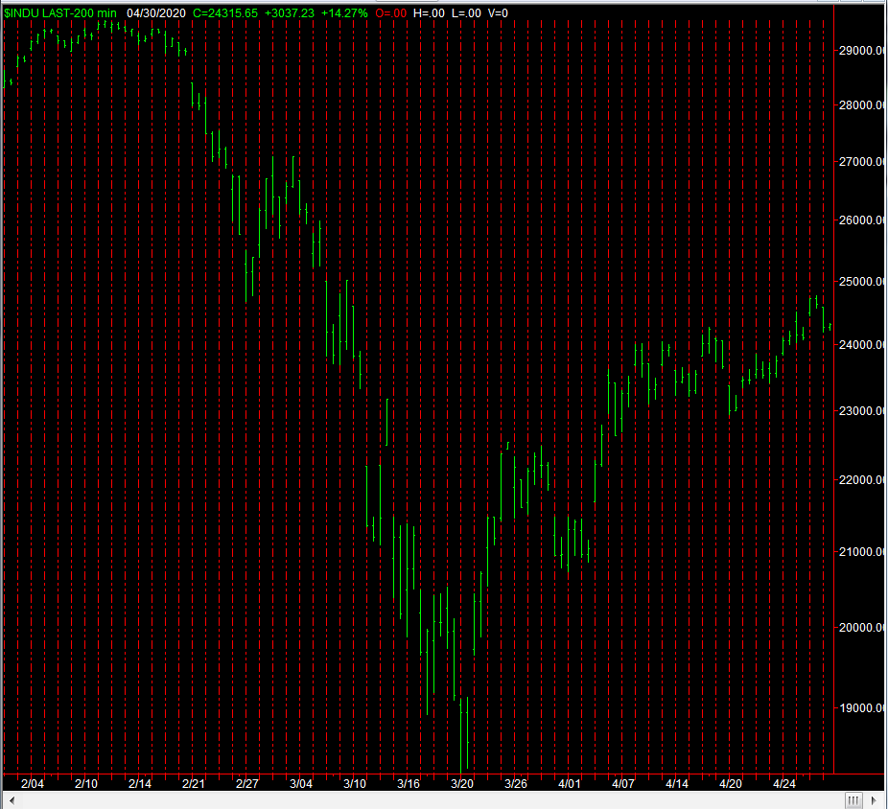

This is what it looked like for the 21 trading days of April 2020:

Apr | -$5,782
 | -$6,253
 | -$4,998
 | -$3,100
 | $63,362
 | $5,717
 | $83,613
 | -$34,040
 | $28,182
 | -$29,861
 | $20,723
 | -$4,586
 | -$4,348
 | $22,575
 | $26,851
 | $21,377
 | $461
 | $43,650
 | $13,781
 | $12,970
 | $12,672
Total Apr | $262,966

And this is what it looks like for 2020 so far:

$ 532,017.09 | Monthly +-
Jan | 28,899
Feb | 244,263
Mar | 530,773
Apr | 262,966
May
Jun
Jul
Aug
Sep
Oct
Nov
Dec
Total 2020 | 1,066,901

We have come close to tripling our initial cash balance in only four months! I have never seen anything like this in 30 years of trading.

